Aha Integration

Jira Integration:

1. Go to workspace setting and choose the product which you want to integrate under the integration section.

1. Choose the Jira and name your integration

1. Configure the account with the proper rights in the both the aha account and jira which means you the right to access and transfer information

1. Select the specific Jira project

1. Mapping Creation from the Jira to Aha

1. Enable is to automatically changes to reflect in the Jira to Aha or vice versa

1. Once done the above configuration and setup now you can make changes in the feature boards in the Aha to integrate it to the jira story or the epic directly.

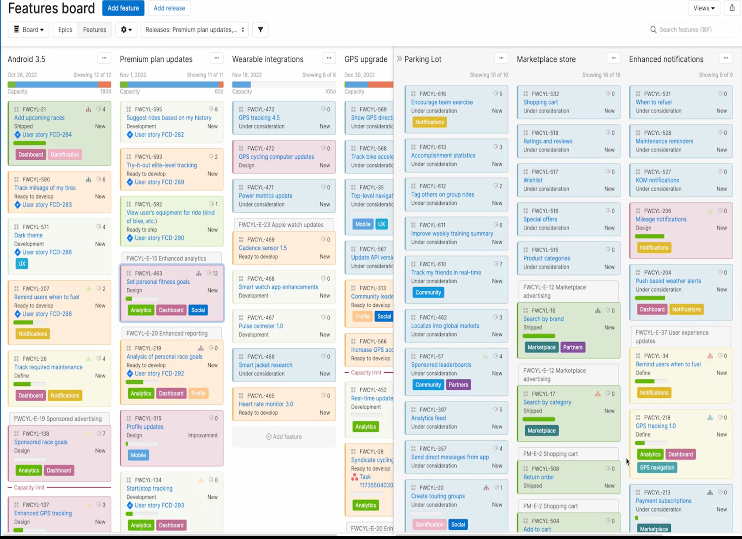

1. Now select the any card on the feature and then select the integration in the card to send it to Jira and you will see the jira link in the integration.

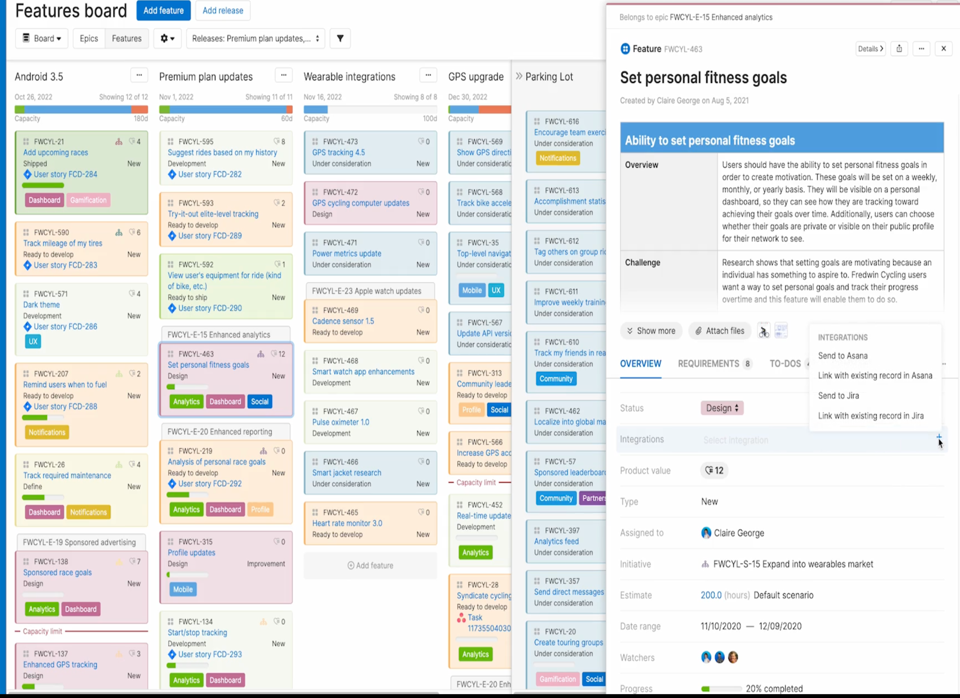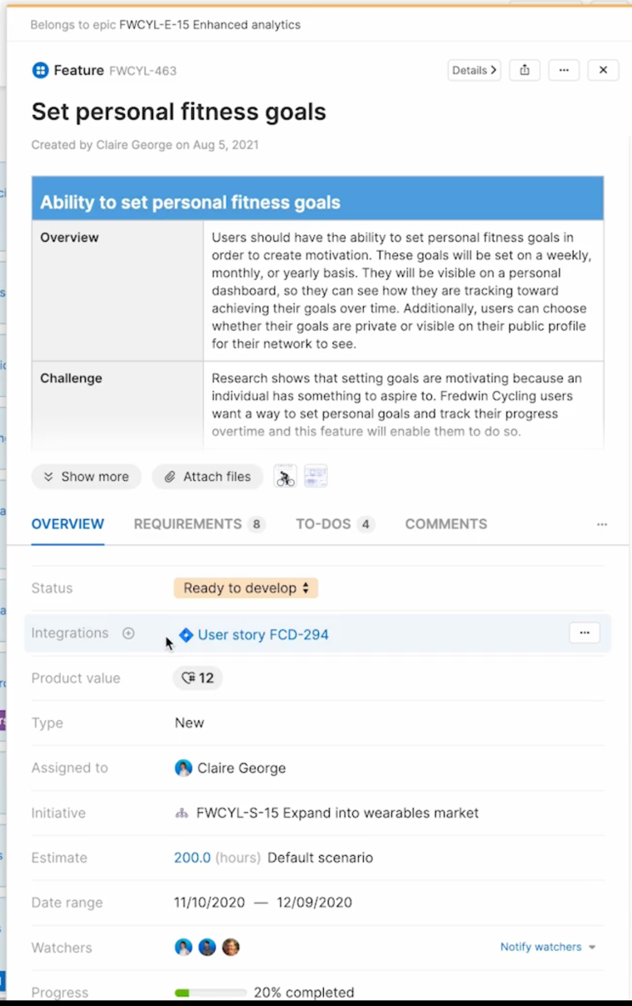

1. Once you integrate if you click on the link it will display all the things that are done in the Jira if the user has the access.

1. You can also import the backlogs from the jira to Aha:

